Fees and Timetable
2023 -2024
There are 4 terms of 9 weeks each
Students should be at the Academy on the 26th of January 2023
Design your own future at a reasonable cost

Academy Fees
Registration
R5 000 is payable which covers the pattern drafting instrument. Non-refundable

Full Time
Monday to Friday from 8h00 to 12h30
R40 000/year payable in advance or R10 000 within 10 days after the classes have commenced each term.
R4 400 X 10 months
Academy fees include fabric used for sewing projects. T&C apply.

Banking details:
ABSA check acc: Acc. name: Bftn Mode Akademie;
Acc. no: 1570 198 102 ; Bank code: 632005
Ref : Name and Surname

How do you apply?
Mail your application to info@bloemfonteinfashion.co.za or hand the hardcopy in at Bloemfontein Fashion Academy, 89 Aliwalstr.
Application should be accompanied by
two testimonials and a
copy of certificate, diploma or school report of last institution attended and your
Proof Of Payment of Registration Fee
Pay slip or 3 months bank statements
Proof of residence
Copy of ID book

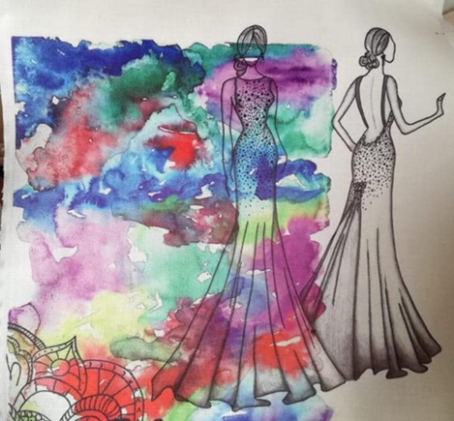
Prospectus
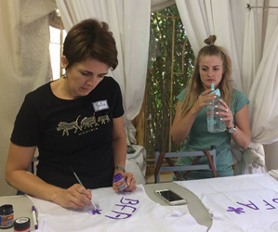
2023-2024
Best Fashion Academy
Bloemfontein Fashion Academy is a private institute that started in 1994 with a minimum number of students. Since then, the Academy has grown fast to a total of 50 students per year from which some has reached great heights. Former students from this Academy have already achieved a lot of success such as starting their own designing studios, training centers, designing for well-known brand names, working overseas and have also done well in design competitions.
Students must have Matric and write an aptitude test before they are accepted at the academy. BFA has a very high standard and an intensive course and therefore dedicated people from all over have joined this academy.
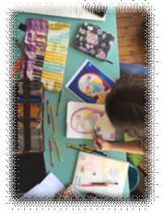
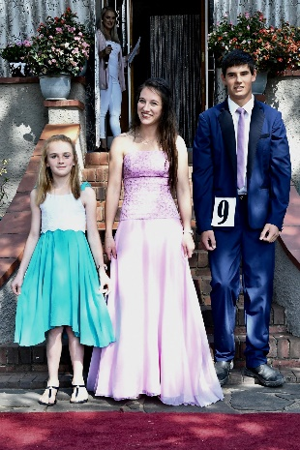
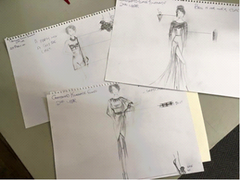
Practical and profession OrientatedThe course consists of a combination of subjects that is woven into one another. Pattern Designing is the major that forms about 70% of the whole course. Students learn how to design any type of pattern for any type of figure. They use a Pattern Drafting instrument that is exclusively designed for the academy. Therefore, clothing fit perfectly every time - it does not matter if it is for the smallest baby or the most gorgeous wedding dress.
In Garment Construction students learn to cut and sew the patterns that they have designed. The course starts with tops and skirts and ends of with proper tailored men’s jackets. The subject Fashion Illustration enables you to sketch a proposal to be presented to a client. Creative art is there to improve the creativity of the students and here they learn to make a lot of interesting things like hats, material painting, shoe covering, etc. To complete the course there is also modules in Textiles, Marketing and History of fashion.
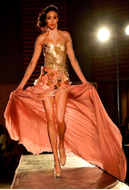
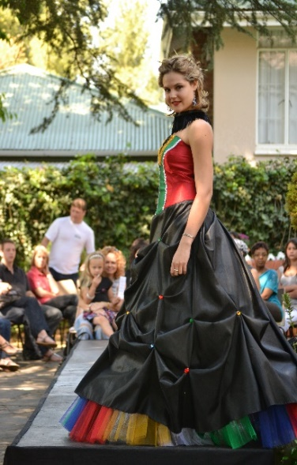

What to expect?
Fashion Shows and Competitions
A gala fashion show is held annually in which the best student designer is chosen. This opportunity opens doors for the students and ensures their position in the world of fashion as well as introducing them to the public.
Competitions outside the academy is also strongly encouraged as this establishes your name as designer.
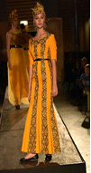
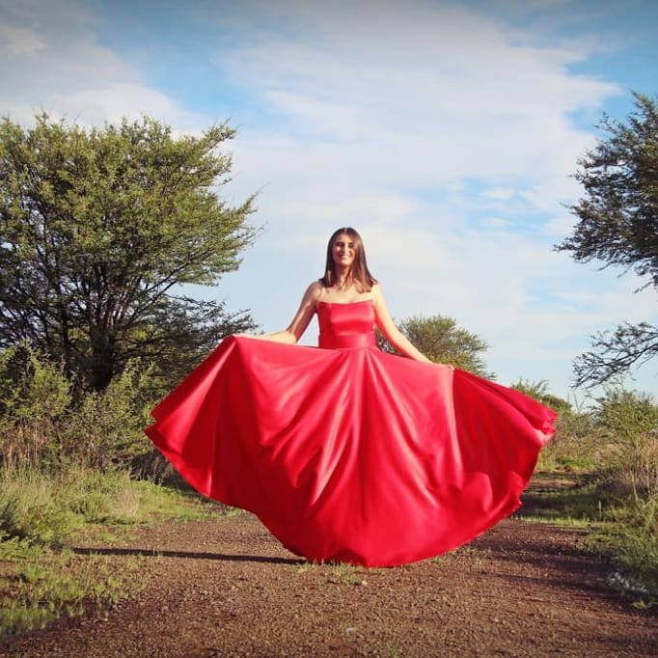
Design
your
own
future!

Fabric Shop!!!
One of our key features at our Academy is that we have a fabric shop on campus to facilitate our students for projects. All our students receive 10% discount on purchases for school and home projects. As the academy fees include materials needed, the students receive a voucher to use in the shop for each project.
*The shop is open to the public.
082 9546 497
051 4306261

